llSPS_INT_1387_Smart Agriculture system based on IoT

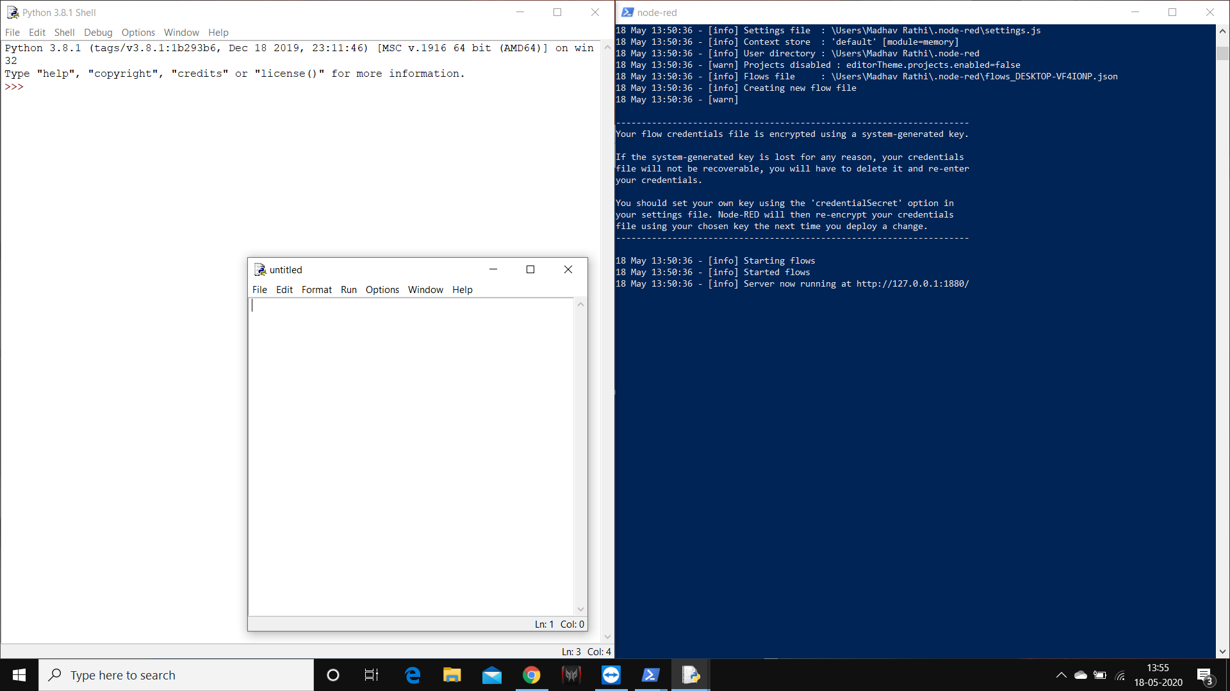

Python IDLE and shell Node - Red on Power Shell